EVALUATION RESULTS

DEEP DATASET TEST LOSS GRAPHİC:
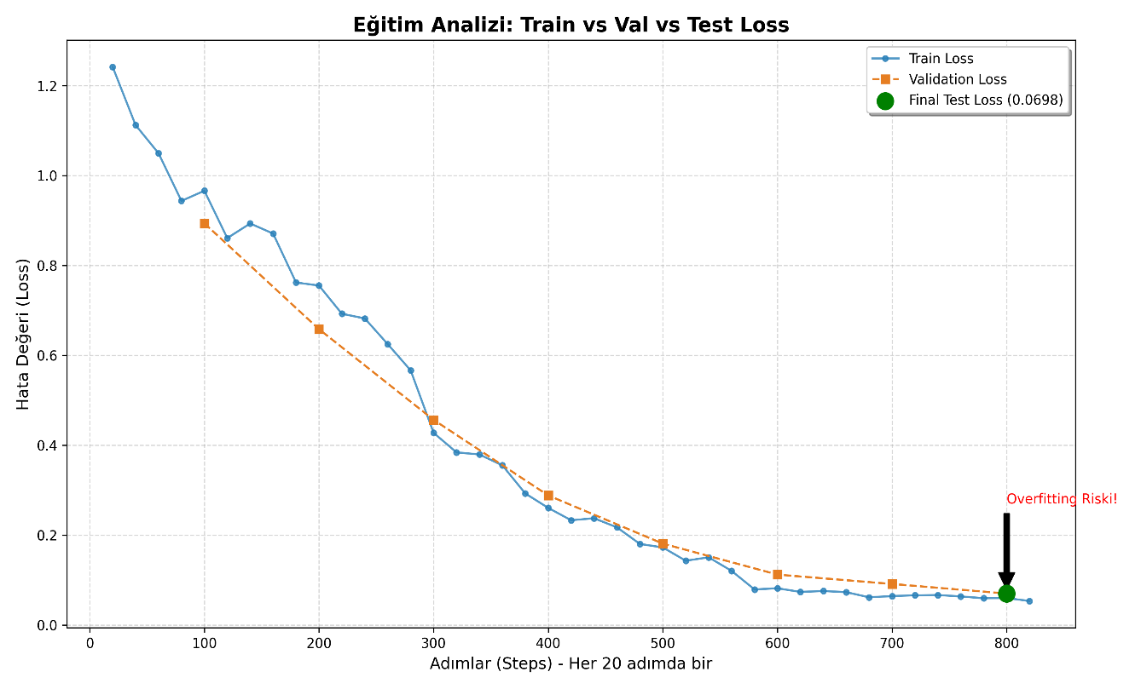
DIVERSE DATASET TEST LOSS GRAPHİC:
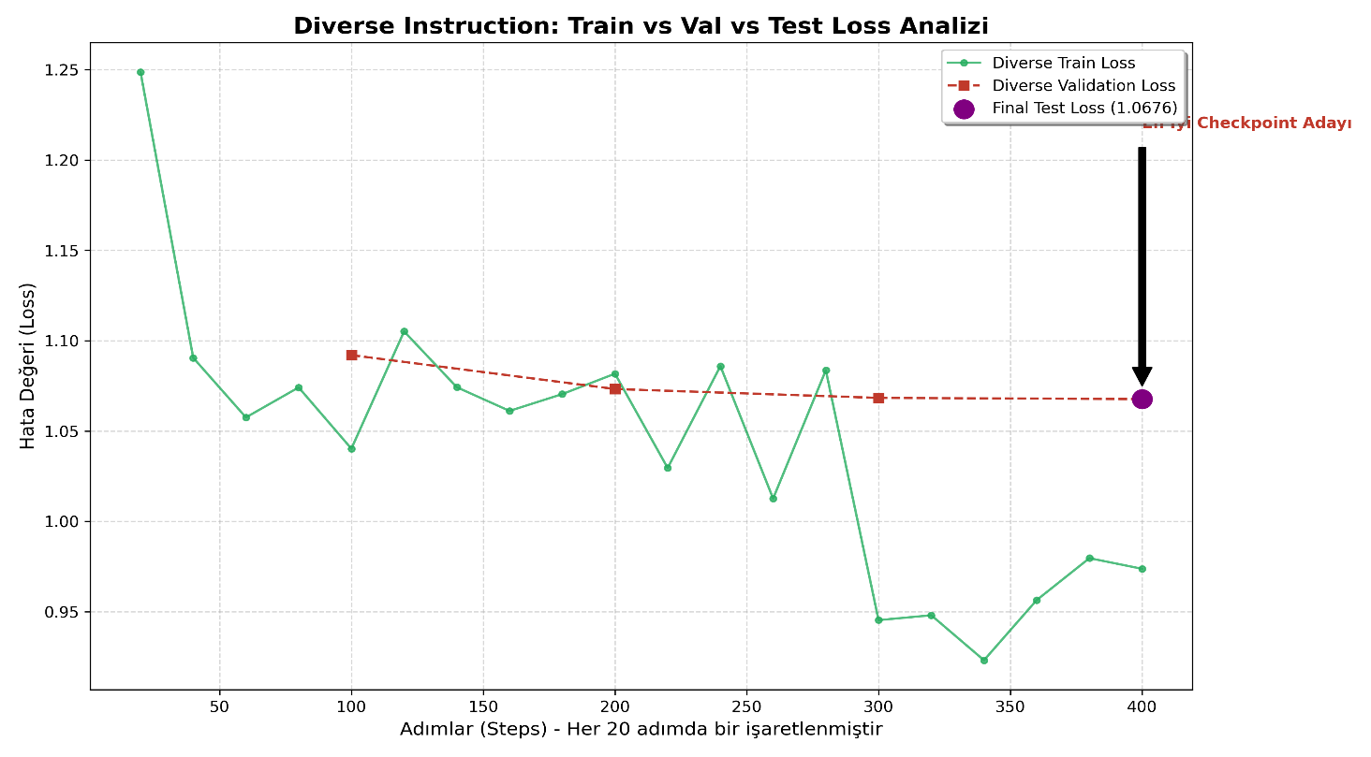

DEEP DATASET TRAINING LOSS GRAPHİC:
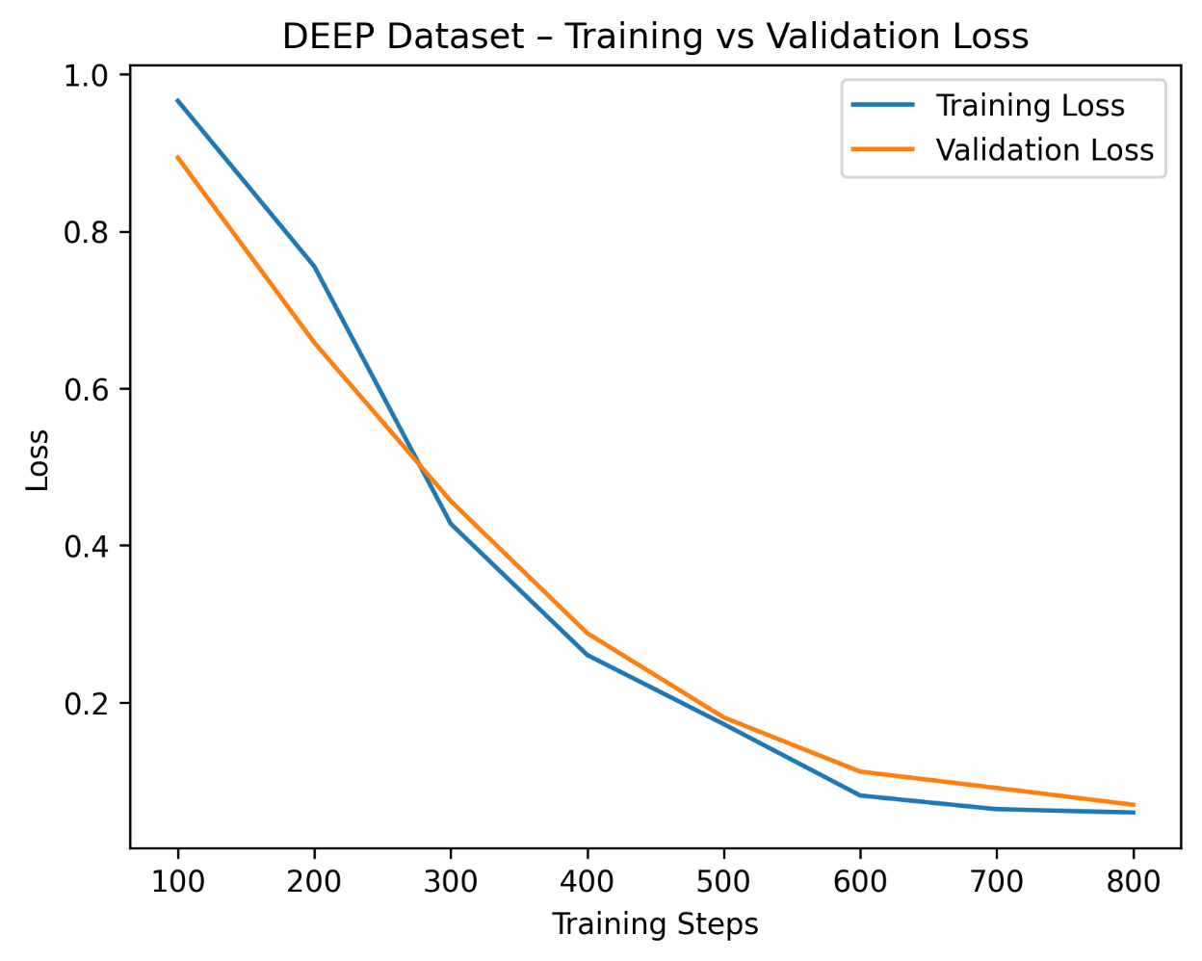
DIVERSE DATASET TRAINING LOSS GRAPHİC:
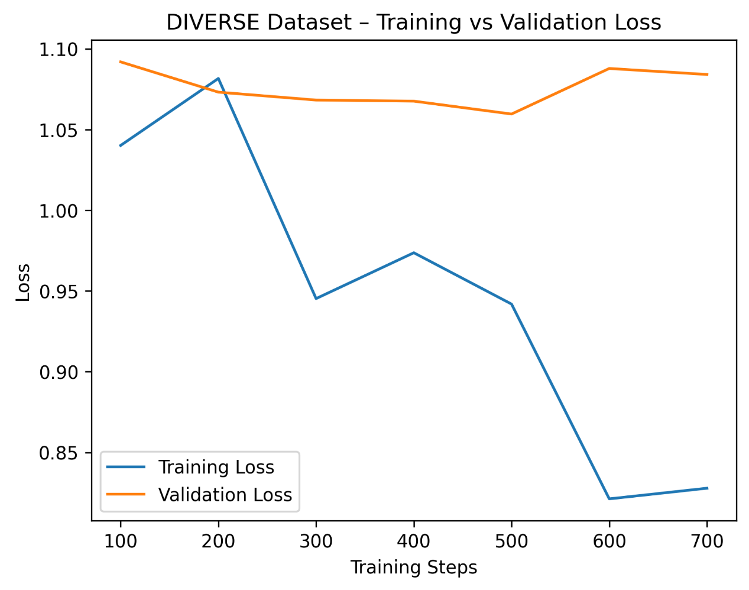

THE BEST CHECKPOINT TABLE :

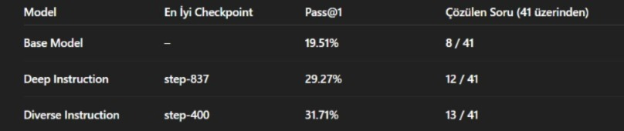

EXPLANATION OF THE LOSS GRAPHICS:

When I trained the datasets, the Deep dataset’s training and validation losses consistently decreased. The fact that the validation loss did not increase indicates that the model did not overfit.
However, for the Diverse dataset, both the training and validation losses increased over time. Since the validation loss rose at least twice, this clearly suggests overfitting. At this point, we apply early stopping. For this reason, I did not include the last two checkpoints in my benchmark test, because the model was overfitting at those checkpoints.

